Image Processing Application – Spring 2021

Lecturer: Professor Lee Guee Sang

Student: Le Hoai Duy – 218493

**Homework 6**

1. Implement homomorphic filtering in frequency domain with Python. Test the code with more than three samples. Discuss the differences.

**Code:**

import os

import cv2

import numpy as np

from PIL import Image

from matplotlib import pyplot as plt

def fft_distances(m, n):

    #calculate the distance of each point of the m, n matrix from the center

    u = np.array([i if i <= m / 2 else m - i for i in range(m)],

                 dtype=np.float32)

    v = np.array([i if i <= n / 2 else n - i for i in range(n)],

                 dtype=np.float32)

    u.shape = m, 1

    # The distance from each point to the upper left corner of the matrix

    ret = np.sqrt(u * u + v * v)

    # The distance of each point from the center of the matrix

    return np.fft.fftshift(ret)

def homomorphic_filter(img, rl=0.4, rh=2, c=5, d0=20):

    # compute ln(img)

    img = np.log1p(np.float64(img), dtype=np.float64)

    #compute fft and fft_shift

    img_fft = np.fft.fft2(img, axes=(0,1))

    img_fftshift = np.fft.fftshift(img_fft)

    #compute mask filter

    duv = fft_distances(*img_fftshift.shape[:2])

    filter_mat = (rh - rl) * (1 - np.exp(-c * (duv * duv) / (d0 * d0))) + rl

    #apply filter by multiple filter_mat and fftshift

    dst_fftshift = np.multiply(img_fftshift,filter_mat)

    #compute inverse fft

    dst_ifftshift = np.fft.ifftshift(dst_fftshift)

    dst_ifft = np.fft.ifft2(dst_ifftshift)

    #combine complex real and imaginary components to form (the magnitude for) the original image again

    dst = np.real(dst_ifft)

    #compute exponential

    dst = np.exp(dst, dtype=np.float64)

    img_homomorphic = cv2.normalize(dst, None, alpha=0, beta=255, norm_type=cv2.NORM_MINMAX, dtype=cv2.CV_8U)

    return img_homomorphic

if __name__ == "__main__":

     path = "./CTI.png"

     img = np.array(Image.open(path).convert('L'))

     img_new = homomorphic_filter(img, rl=0.25, rh=1.5, c=5, d0=20)

     fig, axes = plt.subplots(ncols=2, nrows=1,figsize=(12, 10))

     axes[0].imshow(img, cmap = 'gray')

     axes[0].set_title('Input Image', fontsize=24)

     axes[0].axis('off')

     axes[1].imshow(img_new, cmap = 'gray')

     axes[1].set_title('Homomorphic filtered image', fontsize=24)

     axes[1].axis('off')

     fig.savefig("D:/result_HW6_1.png",bbox_inches='tight')

The homomorphic function is obtained by using a slightly modified form of the Gaussian High Pass Filter function:

$$H\left(u,v\right)=\left(γ_{H}- γ_{L}\right)\left[1- e^{-\frac{cD^{2}\left(u,v\right)}{D_{0}^{2}}}\right]+ γ_{L}$$

**Result:**

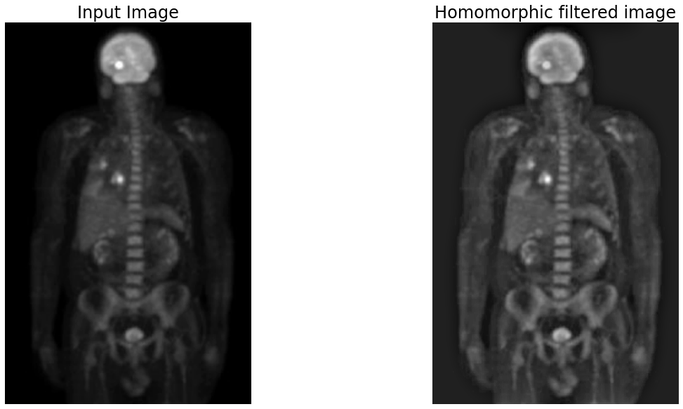

**Figure 1.** Filtered image obtained by the above function with rl=0.3, rh=0.75, c=5, d0=15. The original image is slightly burred and some parts are obscured, specially at arm part. The homomorphic function (obtained by using a slightly modified form of the Gaussian High Pass Filter function) enhances the hidden parts and improves the image's contrast. More details in the image can be seen.

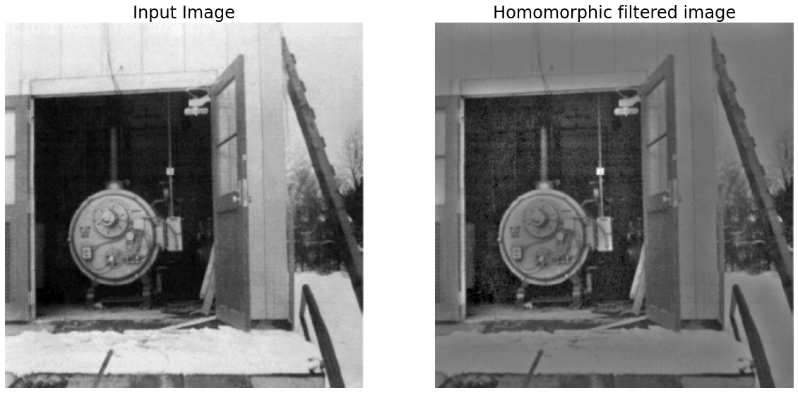

**Figure 2.** Filtered image obtained by the above function with rl=0.3, rh=0.75, c=5, d0=15. More details in the room can be seen.

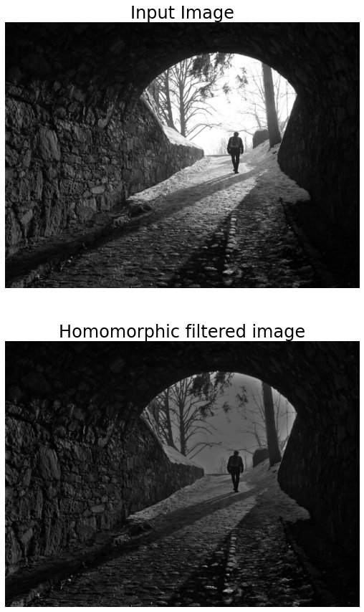

**Figure 3.** Filtered image obtained by the above function with rl=0.75, rh=1.25, c=5, d0=20

2. Implement sharpening with Laplacian, unsharp masking and high boost filtering in frequency domain with Python. Test the code with more than three samples. Discuss the differences.

**Code:**

import os

import cv2

import numpy as np

from PIL import Image

from matplotlib import pyplot as plt

import math

def fft_distances(m, n):

    #calculate the distance of each point of the m, n matrix from the center

    u = np.array([i if i <= m / 2 else m - i for i in range(m)],

                 dtype=np.float32)

    v = np.array([i if i <= n / 2 else n - i for i in range(n)],

                 dtype=np.float32)

    u.shape = m, 1

    # The distance from each point to the upper left corner of the matrix

    ret = np.sqrt(u * u + v * v)

    # The distance of each point from the center of the matrix

    return np.fft.fftshift(ret)

def laplacian_filter(img):

    #compute fft and fft_shift

    img_fft = np.fft.fft2(img, axes=(0,1))

    img_fftshift = np.fft.fftshift(img_fft)

    #compute mask filter

    duv = fft_distances(*img_fftshift.shape[:2])

    filter_mat = 4*(math.pi*math.pi)*(duv * duv)

    #apply filter by multiple filter_mat and fftshift

    dst_fftshift = np.multiply(img_fftshift,filter_mat)

    #compute inverse fft

    dst_ifftshift = np.fft.ifftshift(dst_fftshift)

    dst_ifft = np.fft.ifft2(dst_ifftshift)

    #combine complex real and imaginary components to form (the magnitude for) the original image again

    dst = np.abs(dst_ifft)

    delta = cv2.normalize(dst, None, alpha=0, beta=255, norm_type=cv2.NORM_MINMAX, dtype=cv2.CV_8U)

    laplacian = img - delta

    return laplacian

def unsharp_filter(img,k):

    #compute fft and fft_shift

    img_fft = np.fft.fft2(img, axes=(0,1))

    img_fftshift = np.fft.fftshift(img_fft)

    #compute mask filter

    duv = fft_distances(*img_fftshift.shape[:2])

    filter_mat = 1 + k*(1 - np.exp(-(duv * duv) / (2 * d0 * d0)))

    #apply filter by multiple filter_mat and fftshift

    dst_fftshift = np.multiply(img_fftshift,filter_mat)

    #compute inverse fft

    dst_ifftshift = np.fft.ifftshift(dst_fftshift)

    dst_ifft = np.fft.ifft2(dst_ifftshift)

    #combine complex real and imaginary components to form (the magnitude for) the original image again

    dst = np.abs(dst_ifft)

    img_unsharp = cv2.normalize(dst, None, alpha=0, beta=255, norm_type=cv2.NORM_MINMAX, dtype=cv2.CV_8U)

    return img_unsharp

if __name__ == "__main__":

     path = "./moon.jpg"

     img = np.array(Image.open(path).convert('L'))

     #Laplacian

     img_new_laplacian = laplacian_filter(img)

     #unsharp

     img_new_unsharp = unsharp_filter(img,1)

     #high-boot

     img_new_highboot = unsharp_filter(img,3)

     fig, axes = plt.subplots(ncols=2, nrows=1,figsize=(20, 10))

     axes[0].imshow(img, cmap = 'gray')

     axes[0].set_title('Input Image', fontsize=24)

     axes[0].axis('off')

     axes[1].imshow(img_new_laplacian, cmap = 'gray')

     axes[1].set_title('Laplacian filtered image', fontsize=24)

     axes[1].axis('off')

     fig.savefig("D:/result_HW6_4.png",bbox_inches='tight')

     fig, axes = plt.subplots(ncols=2, nrows=1,figsize=(20, 10))

     axes[0].imshow(img, cmap = 'gray')

     axes[0].set_title('Input Image', fontsize=24)

     axes[0].axis('off')

     axes[1].imshow(img_new_unsharp, cmap = 'gray')

     axes[1].set_title('Unsharp filtered image', fontsize=24)

     axes[1].axis('off')

     fig.savefig("D:/result_HW6_5.png",bbox_inches='tight')

     fig, axes = plt.subplots(ncols=2, nrows=1,figsize=(20, 10))

     axes[0].imshow(img, cmap = 'gray')

     axes[0].set_title('Input Image', fontsize=24)

     axes[0].axis('off')

     axes[1].imshow(img_new_highboot, cmap = 'gray')

     axes[1].set_title('High-boot filtered image', fontsize=24)

     axes[1].axis('off')

     fig.savefig("D:/result_HW6_6.png",bbox_inches='tight')

**Results:**

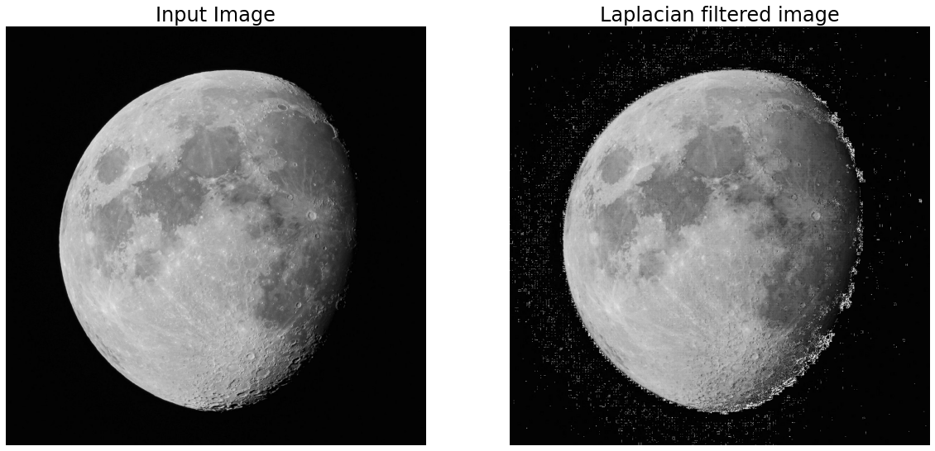

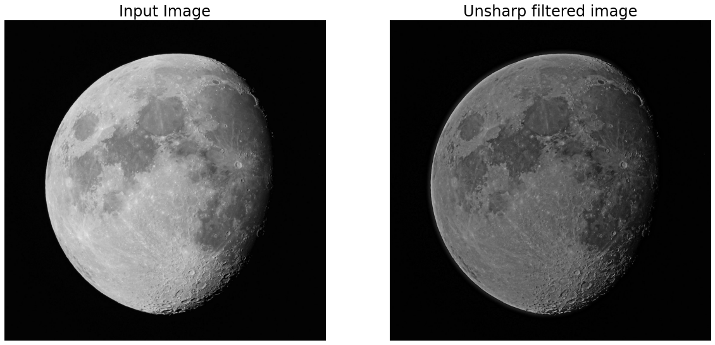

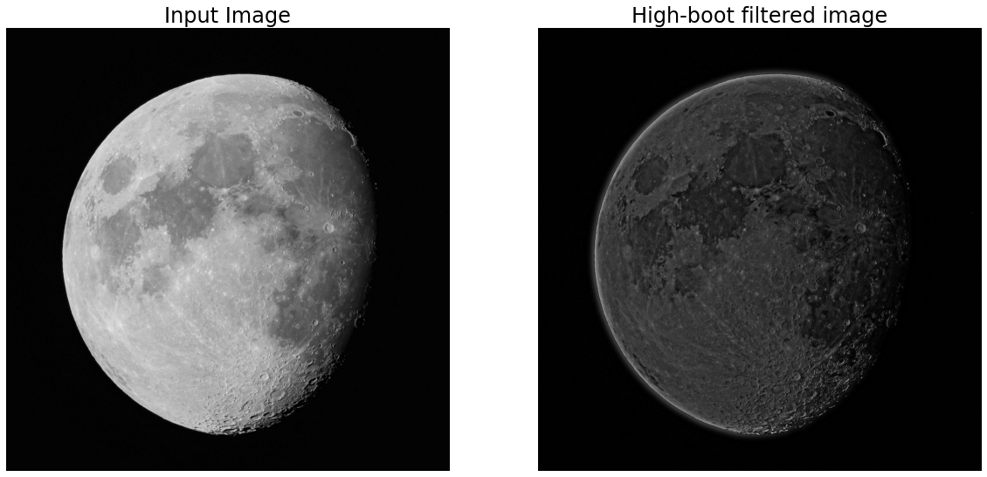

**Figure 4.** Images enhanced using Laplacian, unsharp masking and high-boot in the frequency domain

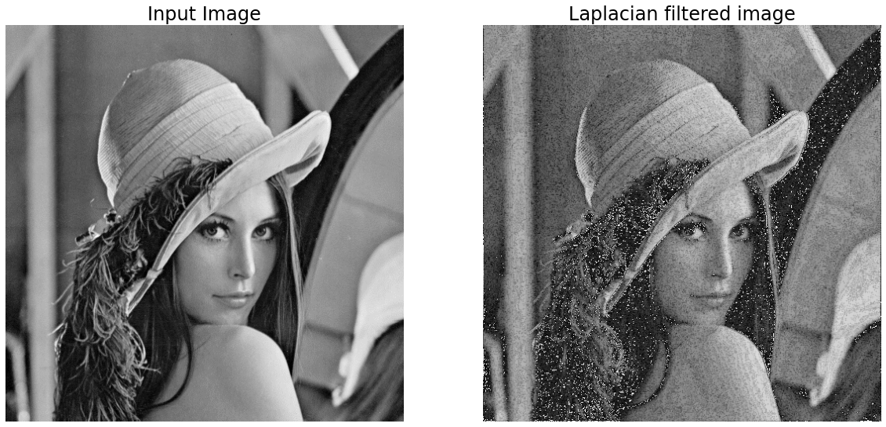

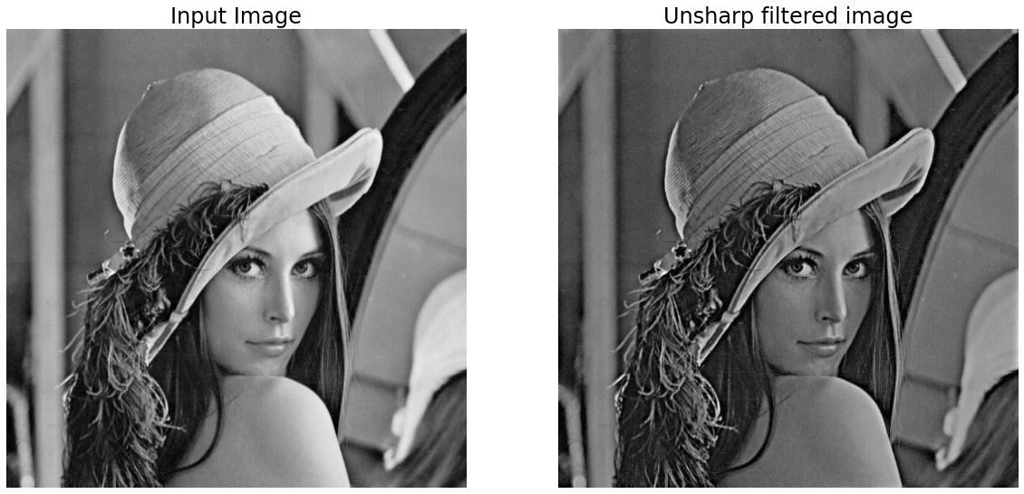

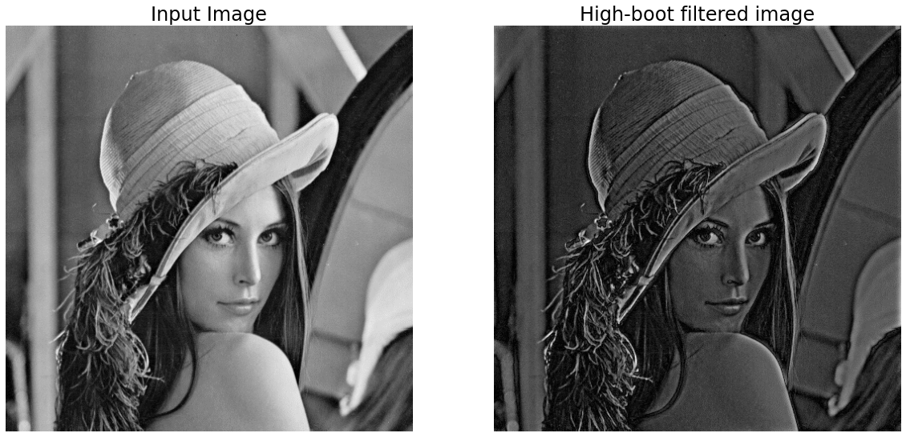

**Figure 5.** Images enhanced using Laplacian, unsharp masking and high-boot in the frequency domain

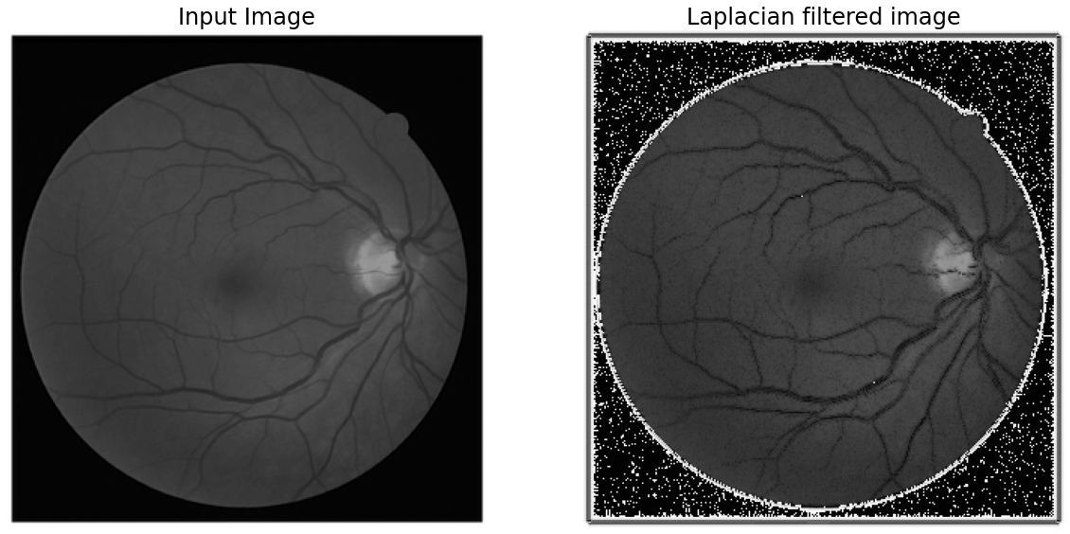

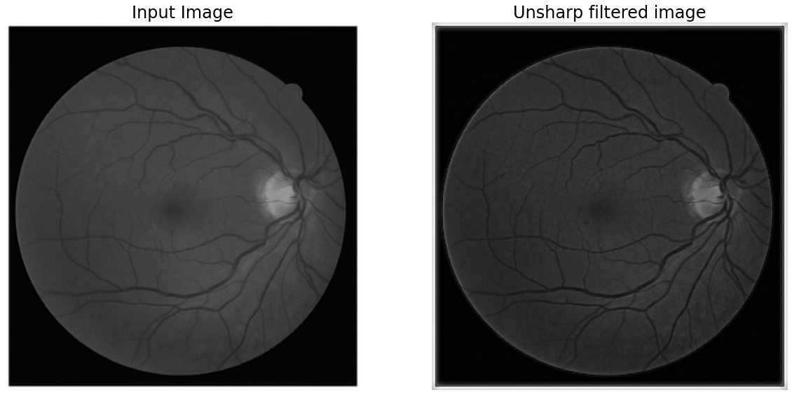

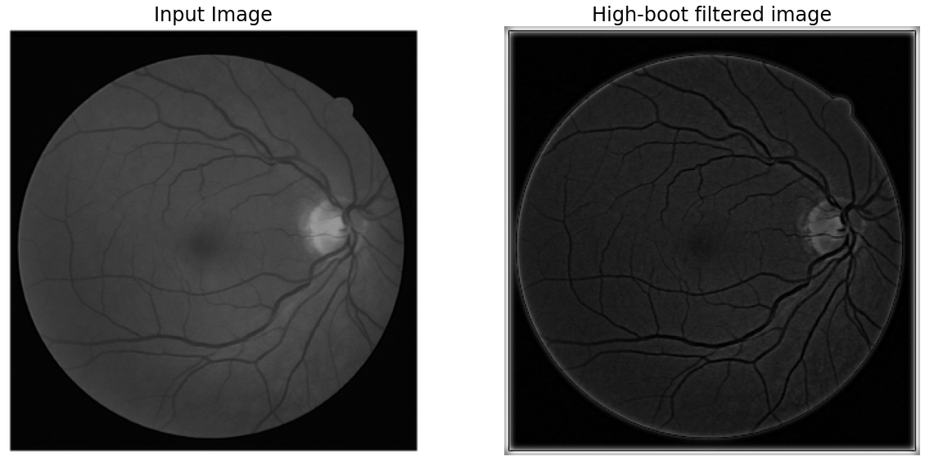

**Figure 6.** Images enhanced using Laplacian, unsharp masking and high-boot in the frequency domain

**Analysis the result:** All 3 methods Laplacian mask, unsharp mask and high boost filtering in frequency domain increase the contrast of the image as well as sharpen the edges, same with in spatial domain.